Assignment 3: Neural Encoding  
Seqian Wang (260377179), in collaboration with Sulantha Mathotaarachchi and Maxime Parent

# Part 1: Reverse correlation

## Recovering the filter

For a random stimulus (white noise input), the cross-correlation of the stimulus and response (output of function oned) gives us the linear filter. We know the actual filter is a vector of length 50 and we expect to find the linear filter where the stimulus and output overlap during the cross-correlation (that is, at length(cross-correlation)/2).

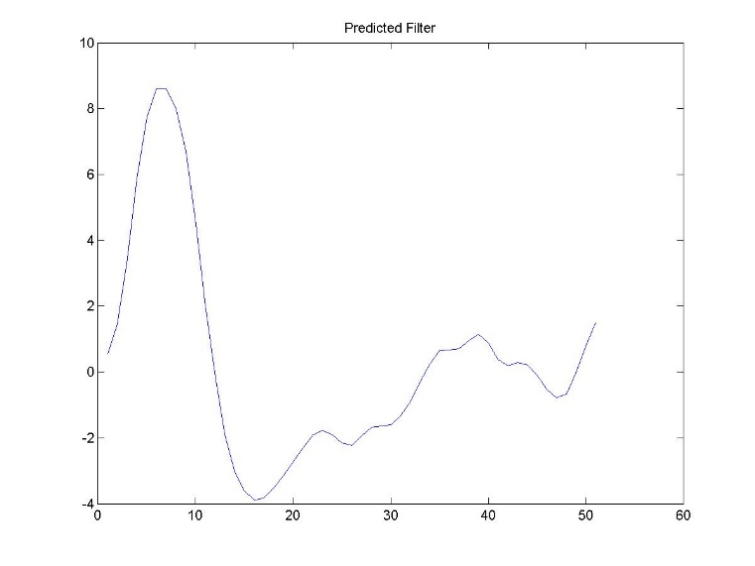

Figure 1: Estimated Filter, extracted from a cross-correlation between input and output. Note that the predicted filter generated here assumes a linear output (with no nonlinearity).

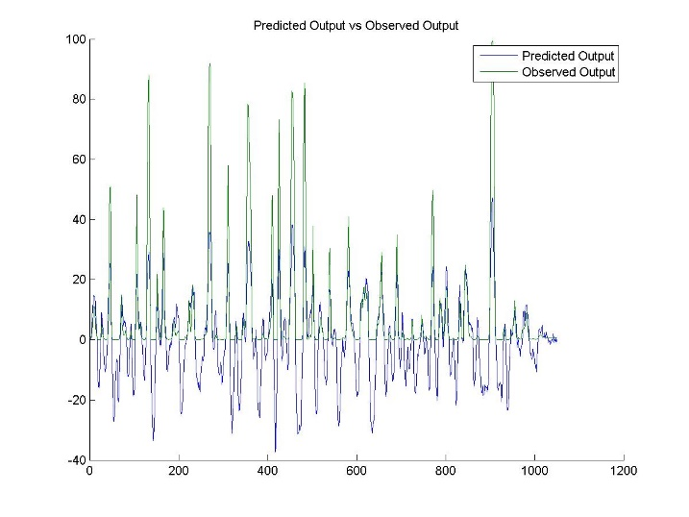

Figure 2: Response after using function oned (Observed Output) vs response after using the predicted filter in Figure 1 (Predicted Output). Unlike the Observed Output, the Predicted Output has negative values, which can be explained by the lack of non-linearity correction in the linear filter. There is a general overlap between the two outputs, with the local maximums corresponding to one another.

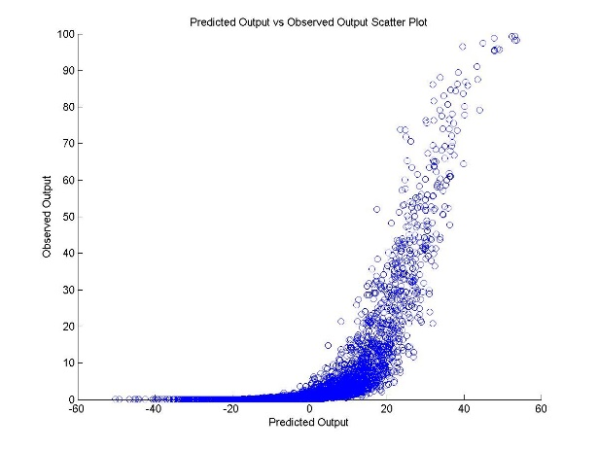

Figure 3: A scatter plot of Observed Output vs Predicted Output. The Observed Output does not go below zero, and its values span the [0,100] range, while the predicted output has a range of [-60,60]. The relationship between the two observations seems nonlinear, with a sigmoid-like shape curve.

## Testing the filter

By applying Equation 2.10, we can correct for nonlinearity with a sigmoid curve.

$$F\left(L\right)=\frac{r_{max}}{1+exp⁡(g_{1}\left(L_{\frac{1}{2}}-L\right))}$$

We changed the parameters g1 and L1/2 in the equation and got the best fit by eye (trial-and-error, g1 = 0.2 and L1/2 = 25). rmax here is the maximum value in the Observed Output (about 100).

Table 1: Mean squared error between the estimated and observed responses as a function of input vector length. The mean squared error values are an average of 50 trials for each vector length. As the vector length increases, the error or difference between the observed and expected decreases as well. As the number of time points increases, the distribution more closely resembles a Gaussian curve, and the variance decreases. Also, the mean squared error with static nonlinearity is smaller than without static nonlinearity. Indeed, since the predicted filter only induces linear changes, we do expect a greater fit and smaller difference between estimated and observed responses after implementing nonlinearity correction.

|  |  |  |
| --- | --- | --- |
| Input Vector Length | Mean Squared Error before static nonlinearity | Mean Squared Error after static nonlinearity |
| 100 | 622.9 | 471.4 |
| 500 | 442.1 | 230.5 |
| 1000 | 360.8 | 139.8 |
| 2000 | 300.9 | 87.6 |
| 5000 | 254.3 | 64.0 |

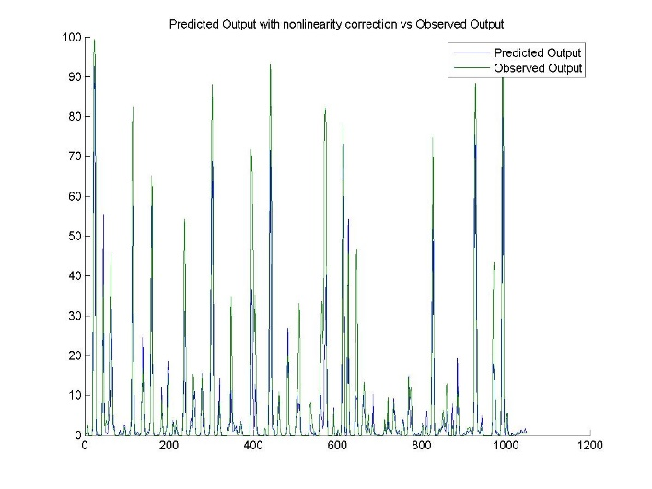

Figure 4: Predicted output after non-linear correction vs observed output. With the nonlinear correction described, the predicted output can have a much better fit with the observed output, as shown in the figure. This has been generated using an input vector length of 1000.

# Part 2: Spike-triggered averaging with a three-dimensional input

The temporal response is the output after going through the linear filter. We know that for a given stimulus, the peak of the response occurs 8 units of time later and the trough 16 after in the linear filter. Thus, we can use spikes indexes to find the corresponding spatial receptive field in the input matrix.

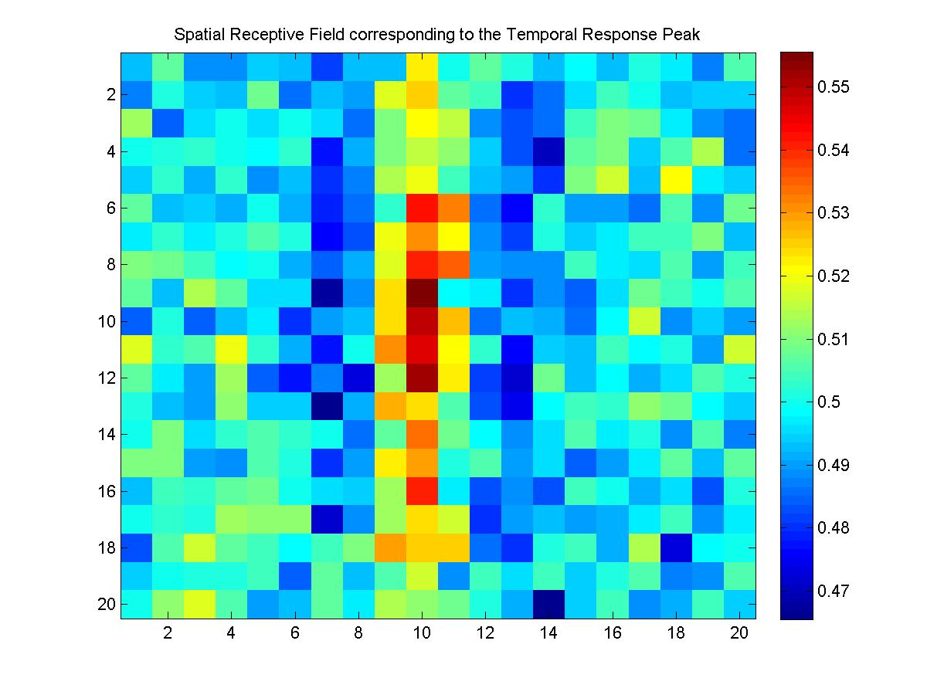

Figure 5: Spatial Receptive Field corresponding to the Temporal Response Peak. Since the filter peak represents the maximum response of the neuron, we can infer from the figure that the preferred orientation of the neuron is vertical.

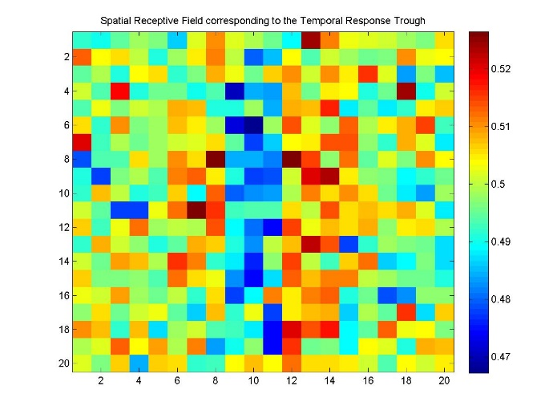

Figure 6: The spatial receptive field corresponding to the temporal response trough shows the image with induces the minimal neuronal response. Compared to the spatial image with the peak response, the image is inversed, the vertical line in the middle is “off” and the surrounding “on”. This behaviour corresponds well with the orientation-selective V1 cells found in the visual cortex.